**Tri-Finger Gripper**

**Phase 2**

Spring Semester 22/23

Zhiyuan Li- 941190894

Yousef Darwish - 314928961

Contents

Abstract 2

Review of winter semester 2

Work plan 3

Final Design in Creo 4

Motor Selection 6

Programming in Arduino 6

Final Assembled Tri-finger 7

Simulation in ROS Gazebo 9

Gripper Test on Robotic Arm 10

Reference 14

# Abstract

Tri-finger gripper is known for its good performance on flexibility and reliability. With the separately actuated finger, it is able to adapt its configuration to different geometry shapes and carry a relatively large payload compared to its own weight.

The purpose of this project is to design and build a tri-finger gripper which is capable of grasping cylinder-shaped objects with no-friction contacts and against gravity in the experiment. As part of the project, multiple designs were proposed and kept being selected and modified until an appropriate prototype was determined. Then, the gripper was manufactured and assembled, and its feasibility was proven by the on-hand preliminary testing. In the next stage, our group integrated the Arduino-powered gripper with ROS and created an interface between the gripper and the robotic arm. The practicability and maneuverability of the gripper are tested with it connected to the robotic arm end in the experimental stage.

# Review of winter semester

The main focus of the previous semester was the mechanical design of the tri-finger gripper through continuous iterations and improvement until an appropriate prototype was determined.

After finishing the model construction in Creo, the critical parts of the gripper were first manufactured to verify the feasibility and practicability of selected design. Force analysis of the mechanical structure was simultaneously performed to guarantee design validity and avoid potential defects [1]. Shown below is the iteration of designs in the past semester.

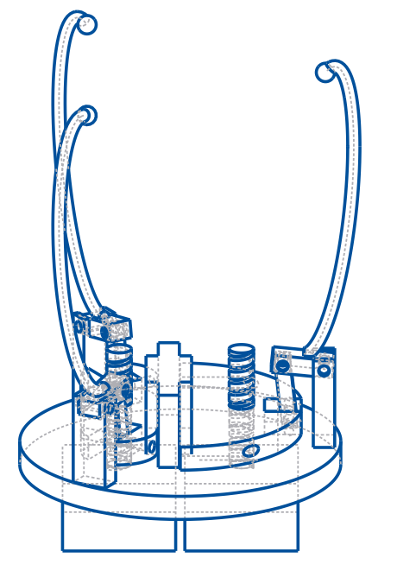 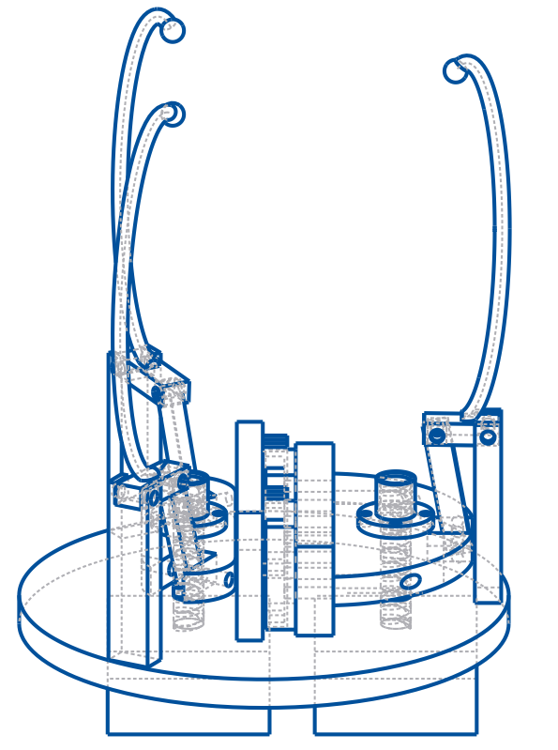 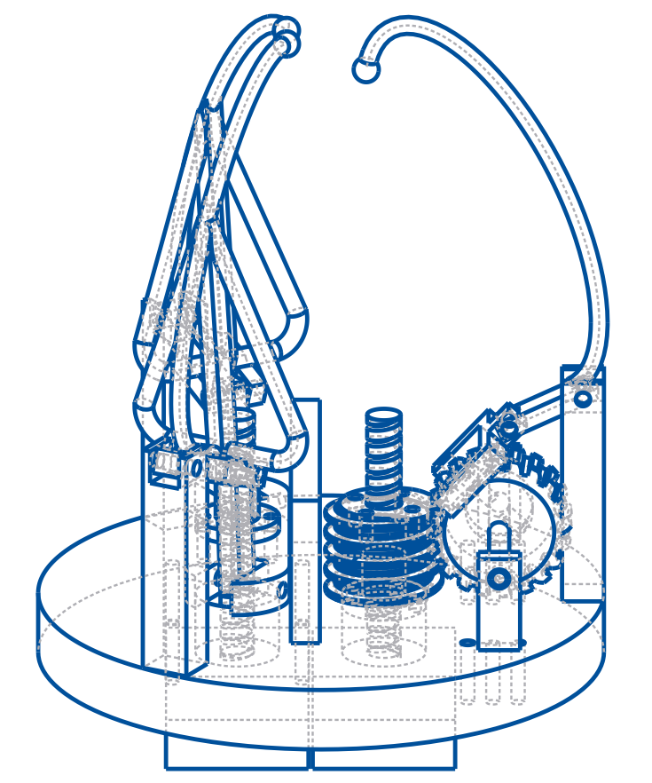

*Figure 1: iteration of designs in winter semester*

# Work plan

In the beginning of the spring semester, we will produce all required parts using 3D printer, and also prepare metal components such as worm-gear and power screw. Then, part assembly, motor selection and installation will be performed. Next, the project will move to the programming and experimental stage. Our group will integrate the Arduino-powered gripper with ROS and create an interface between the gripper and the robotic arm. After that, we will perform the gripping test by controlling the robotic arm with the gripper connected.

# Final Design in Creo

This semester, we added a few modifications to the previous designs including adjustment of worm-gear interaction, the thickness increment of the finger, as well as an addition of a connector which joins the gripper to the end of the robotic arm. Illustrated below is the two-dimensional drawing of the final gripper model in an open state with multiple perspectives. Part of the important dimensions are annotated. A rescaled isometric view of the gripper is also added at the top right corner for reference.

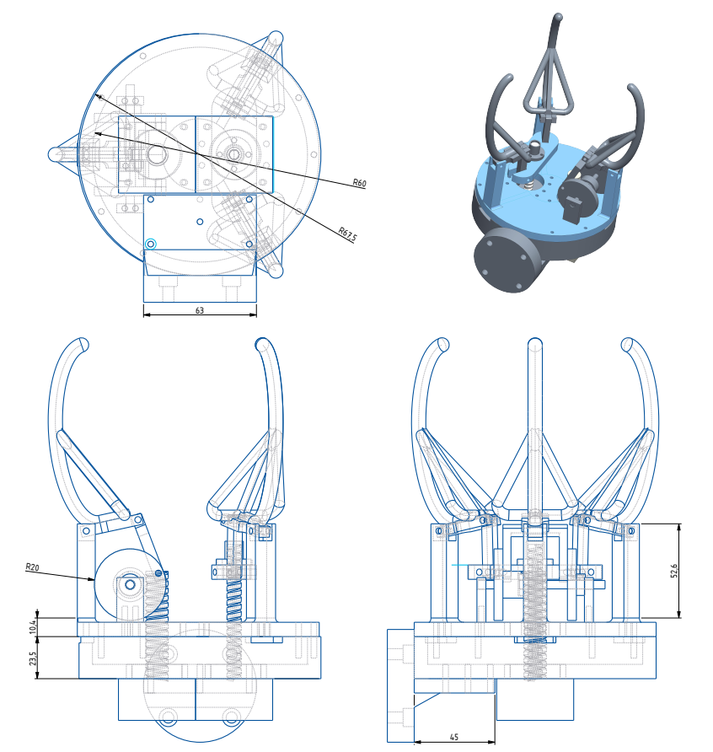

*Figure 2: Two-dimensional drawings of the model in open state along with the rescaled isometric view*

We can also illustrate the related two-dimensional drawings and isometric model when the gripper is in closed or grasping state, as is presented below. The rescaled isometric view of the gripper can also be found at the same position.

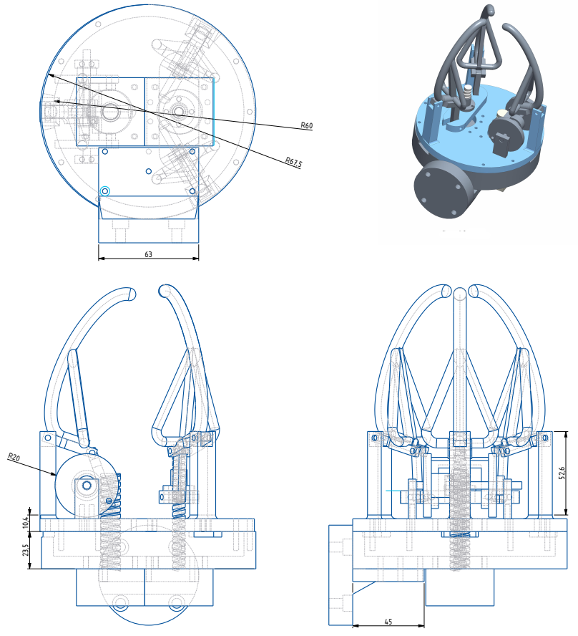

*Figure 3: Two-dimensional drawings of the model in closed state along with the rescaled isometric view*

# Motor Selection

Since we hope to control one of the fingers separated, two motors are required for the gripper. We chose MECURY MOTOR SM-42BYG011-25, a very powerful stepper motor with a 4-wire cable attached. This kind of motor is inherently open-loop, able to make precise moves without feedback regarding motor position, which is an appropriate fitting to this project. Shown below is the schematic diagram of the circuit built for the gripper, it should be noted that since we are using A4988 stepper motor driver in the end, the actual circuits differ a bit in some of the parts.

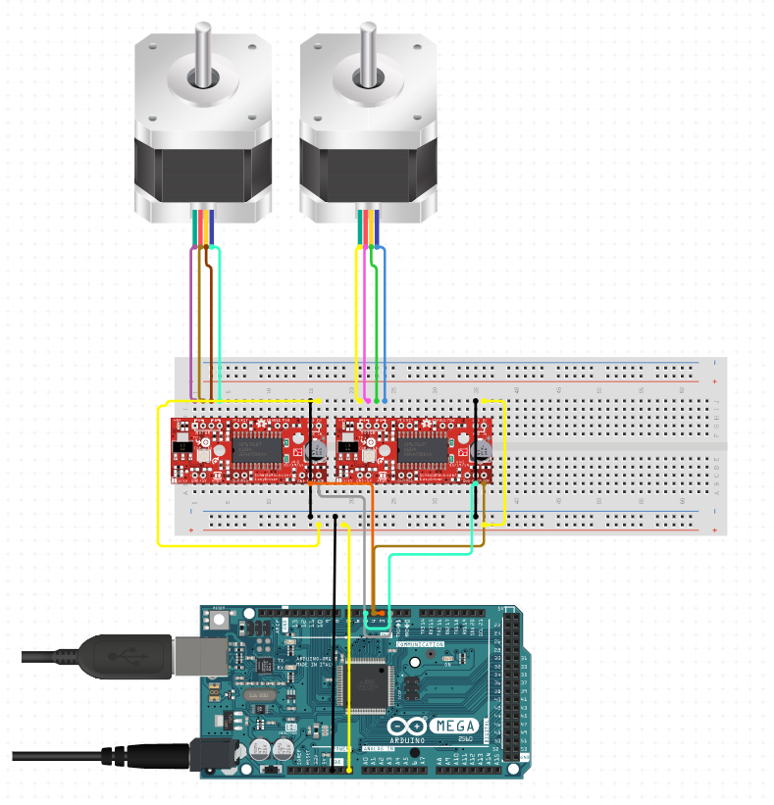

*Figure 4: Schematics diagram of the motor driver circuit connected to the Arduino Mega 2560.*

# Programming in Arduino

The full Arduino codes allow the following functions:

* Separate control of two motors, rotation speed, direction and number can be specified for either of the motors.
* Simultaneous or separate activation of both motors.
* Circuit breaker: when the input voltage to the motor exceeds the safety margin, which is set as 15 Volt in our case, the motor will automatically enter the sleep mode and the LED light connected to the circuit will start to flash. This part of the code is for the safety use of the external power source and avoid potential risk of erroneous initial voltage.

# Final Assembled Tri-finger

The gripper is assembled from the buttom (Arm&Gripper Connector) to the top parts including fingers as well as the lifting platform transmitting mechanical power between the power screw and the fingers.

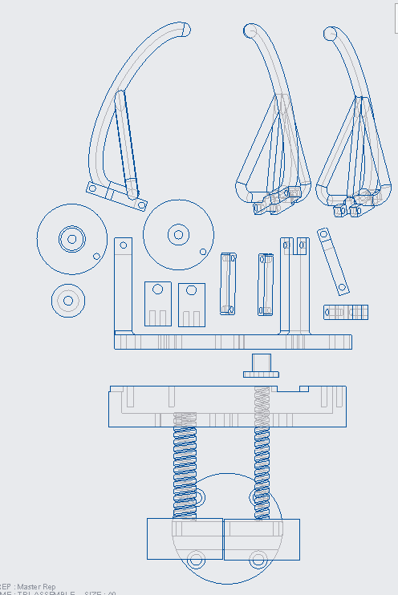

*Figure 5: Explosion view of the Tri-Finger Gripper*

The figure below illustrates how everything looks after integrating all parts including the gripper itself, Arduino Mega 2560 board, and A4988 stepper motor drivers (External power sources are not included in this figure)

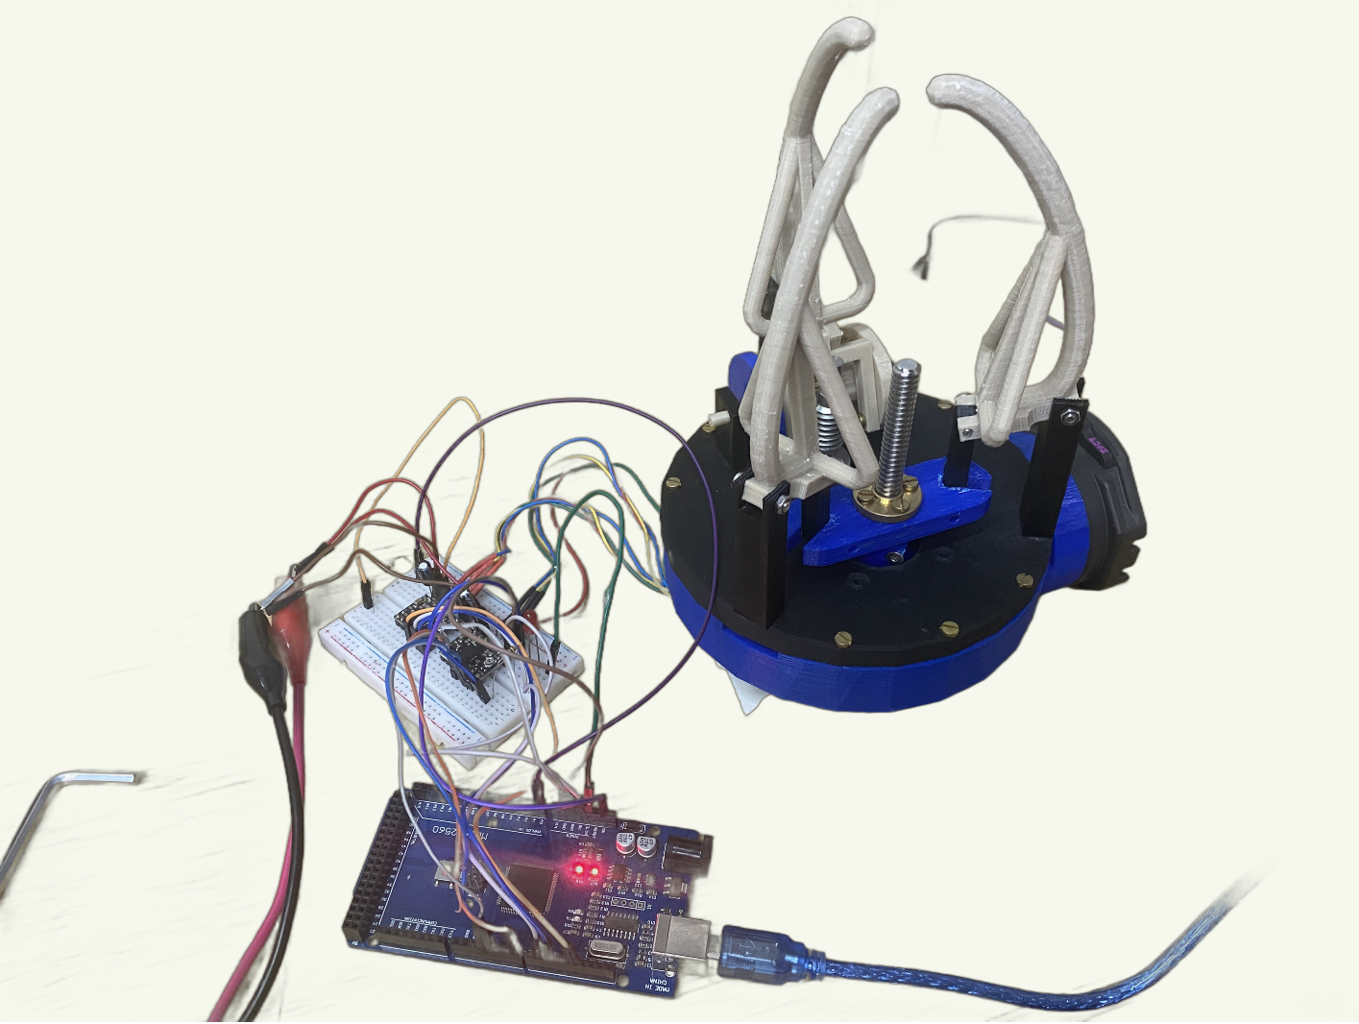

*Figure 6: Tri-finger Gripper after integrating Arduino Mega 2560 board, and A4988 stepper motor drivers.*

# Simulation in ROS Gazebo

Shown below is the simulation of the Tri-finger gripper in ROS Gazebo. We only present simulation of the 1st gripping mode here, the analysis of another gripping mode can be found in next section.

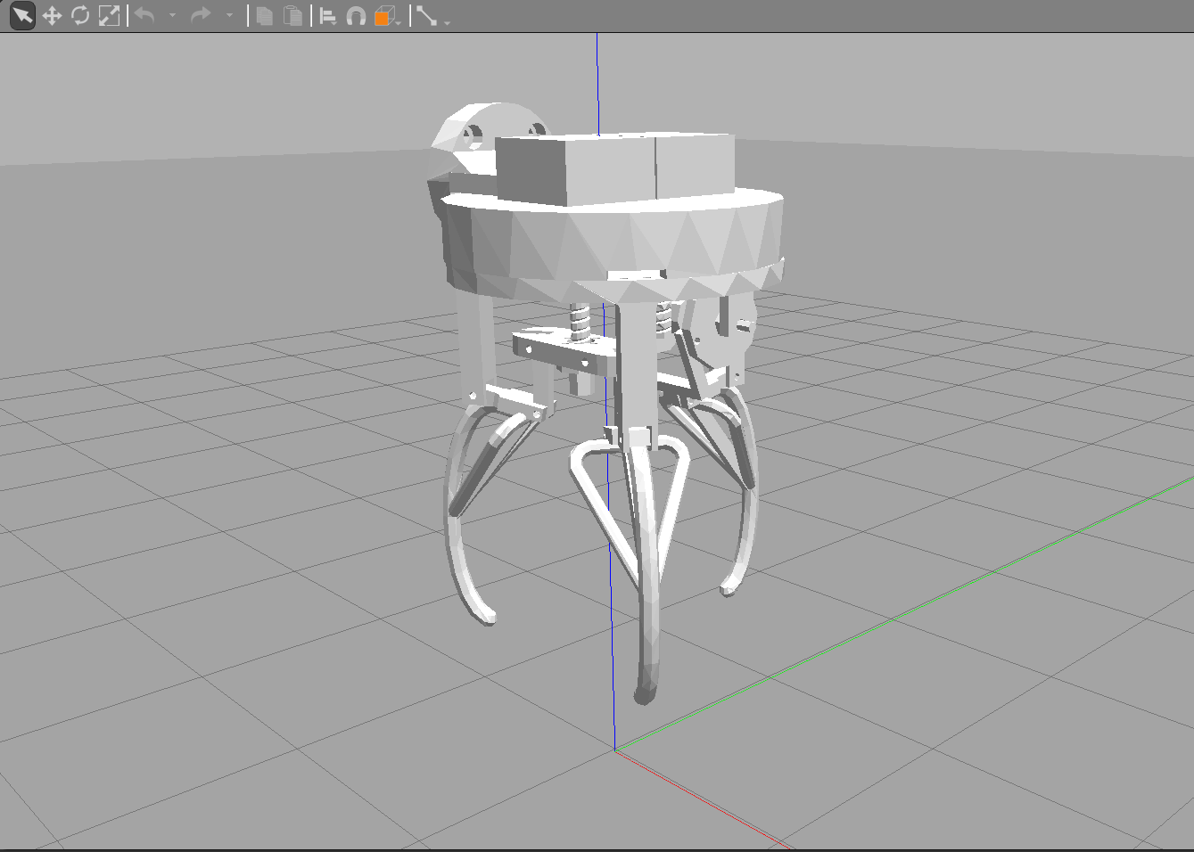

*Figure 7: Simulation of the gripper in ROS Gazebo (In open state)*

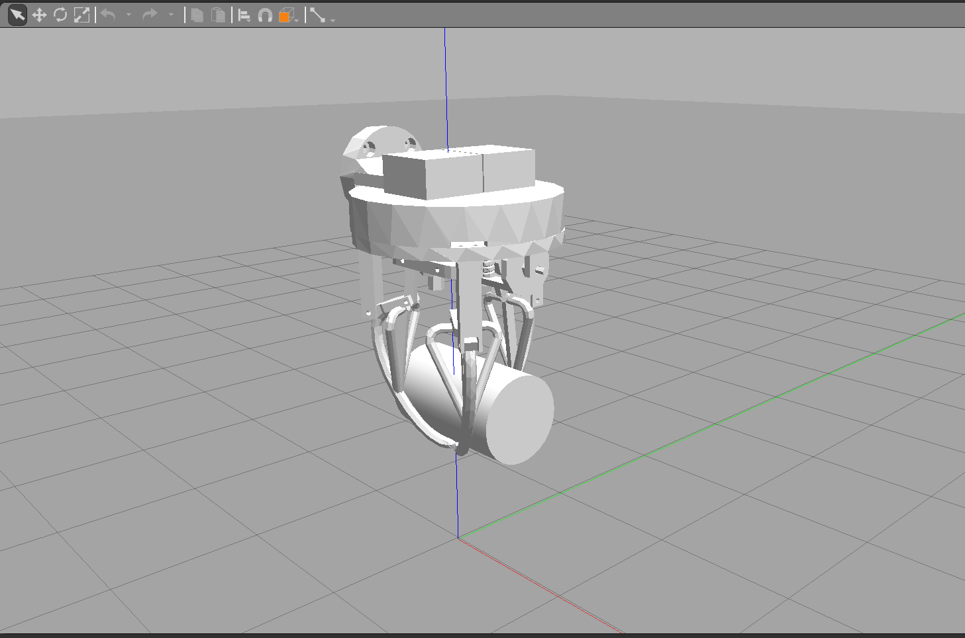

*Figure 8: Simulation of the gripper in ROS Gazebo (In grasping state)*

# Gripper Test on Robotic Arm

There’re two possible gripping modes for this gripper.

1st mode:

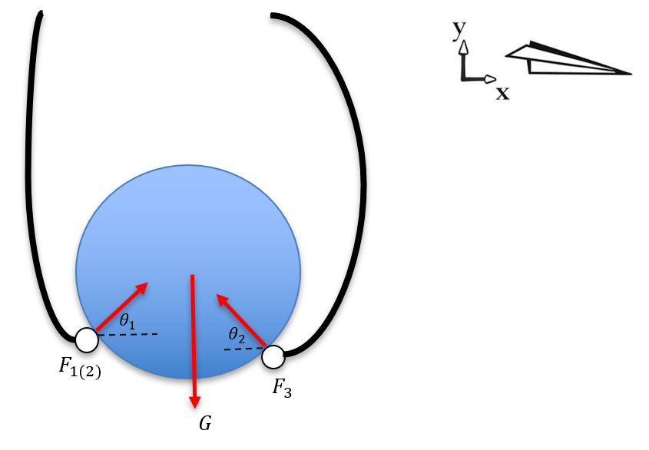

*Figure 9: schematic front view of the 1st gripping mode along with the excerted force.*

As we have discussed in phase-one report, we’ll target cylinder-shaped geometry with no-friction contacts and against gravity, so the front view when grasping the payload might look like below. Remember that the top view of the contact point will be an isosceles triangle, and in the current view, two points on the bottom side will coincide with each other. Assuming they are on the left side in this figure. Denote the mass weight as , solving force and torque balance gives:

The finger is produced using Polylactic Acid (PLA) with filling rate. From online we know the tensile strength of pure PLA is 18.77 MPa, and since it’s a point-contact grip, we assuming the effective contacting area to be a circle with a diameter of , and is . In the end, we get that the maximal weight the gripper can lift is approximately , which is . However, considering the joint connection and safety factor, we suggest the lifting not exceeding In addition, we don’t hope the gripped cylinder to slide horizontally when the gripper is travelling together with the arm. Assuming the cylinder is placed horizontally, force balance gives us the following equation , and we get the acceleration the arm at gripper end shouldn’t exceed:

Where, is the static friction coefficient of the cylinder being grasped, is the acceleration of gravity.

Shown below, is the state when the gripper is connected to the arm end and holding the cylinder in its 1st gripping mode.

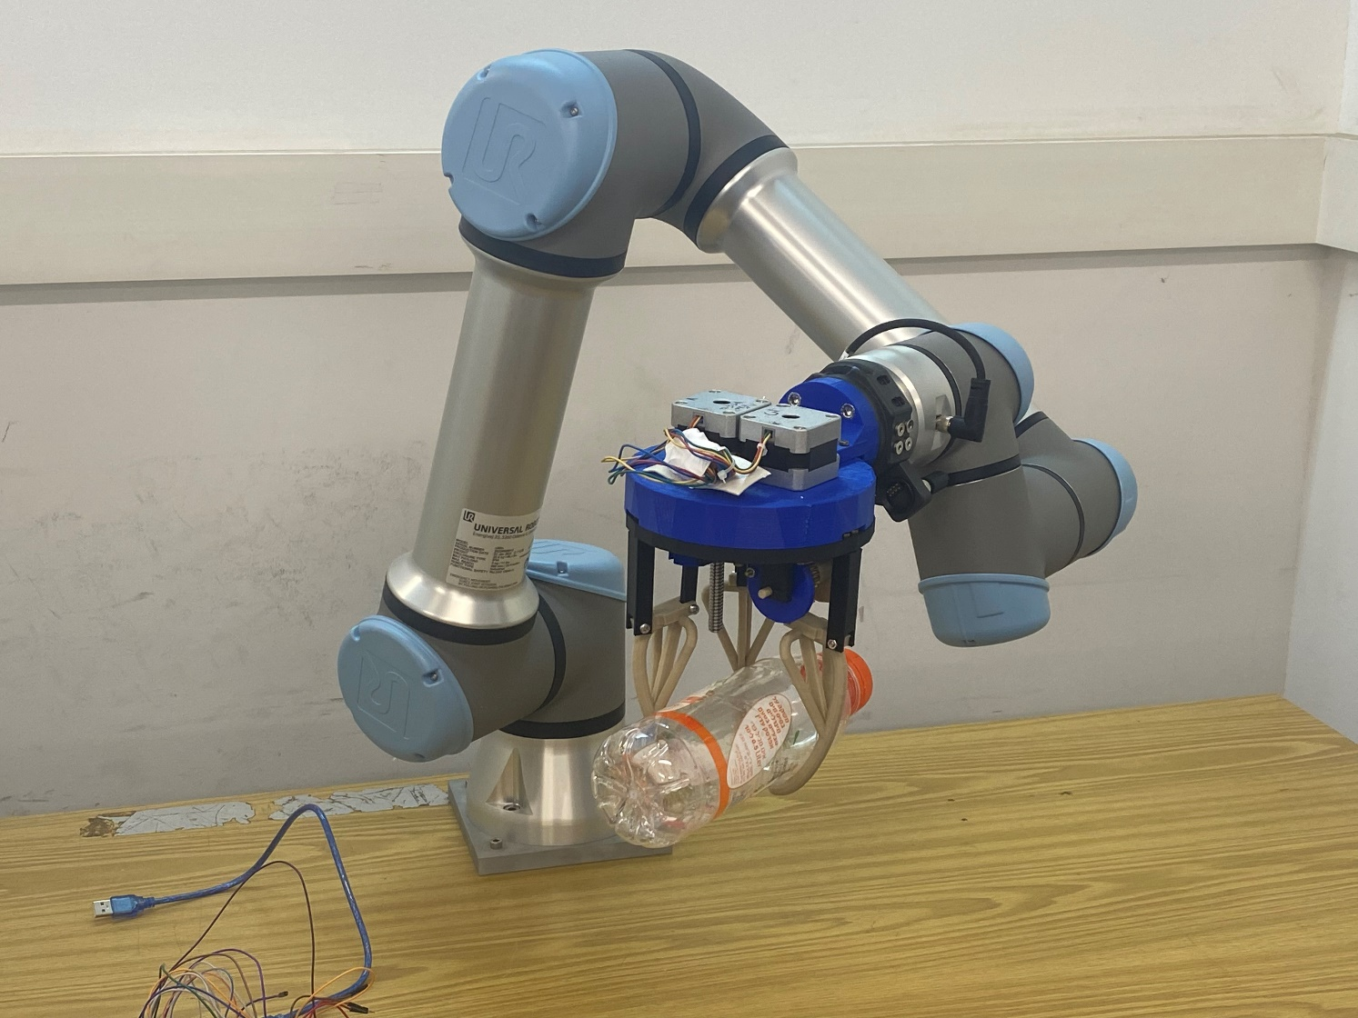

*Figure 10: Gripper and the arm in 1st gripping mode.*

2nd mode:

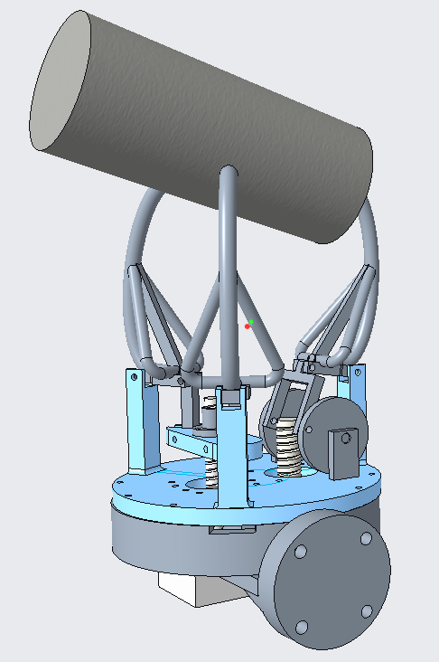 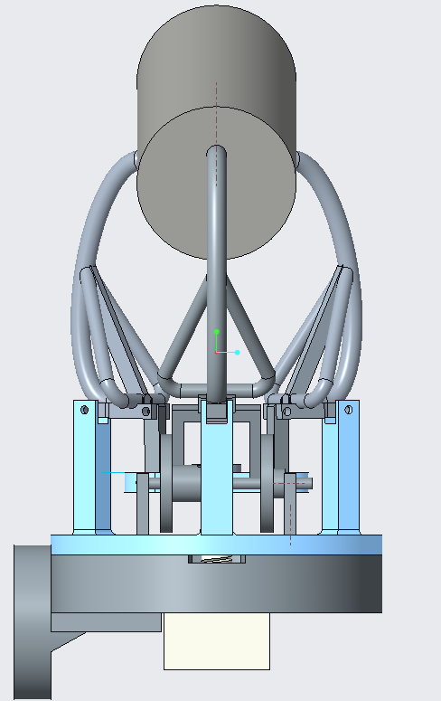

*Figure 11: 2nd gripping mode with different views*

We can do a ***simplified*** analysis to find the force excerting on the cylinder. Assuming the two contacting points on one side are completely sysmetric to each other, and the contacting point of 3rd finger is vertial to the cylinder base, and on the surface of symmetry, as we can see in the side view of the gripping mode.

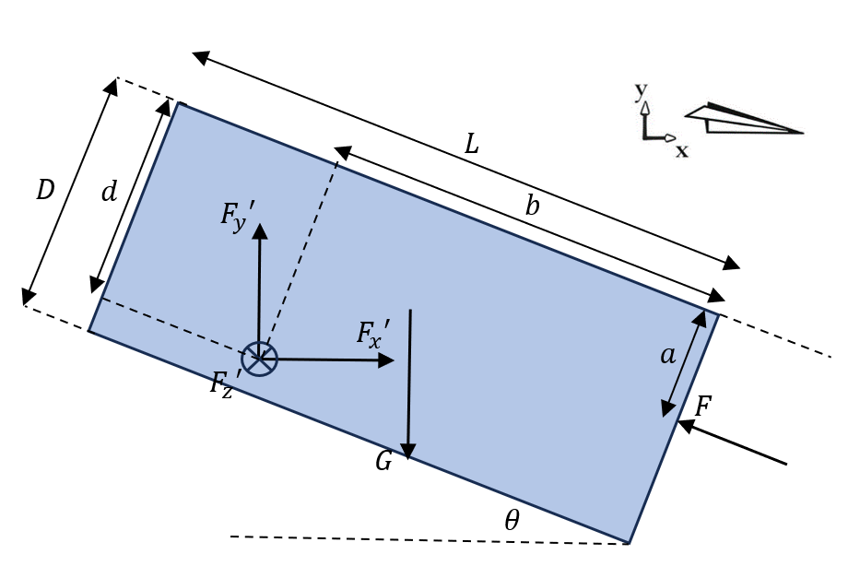

*Figure 12: schematic front view of the 2nd gripping mode along with the excerted force.*

Assuming the two force vectors and on other side are completely sysmetric to each other, which automatically give force balance in direction, and torque balance except direction . Using remaing force and torque balance:

Solving this equation system, we get

Shown below, is the state when the gripper is connected to the arm end and holding the cylinder in its 2nd gripping mode.

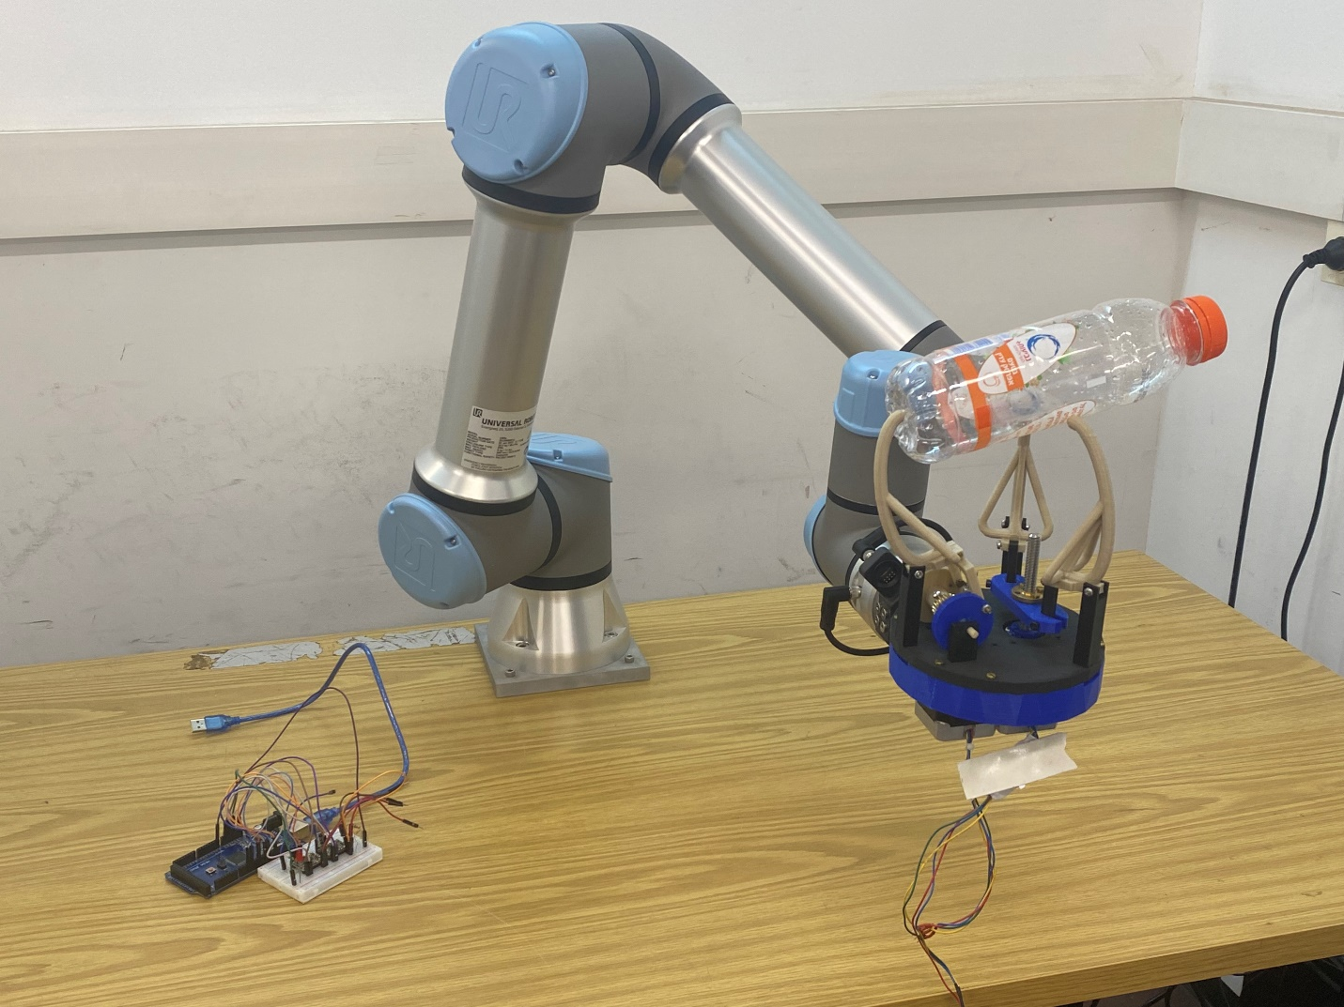

*Figure 13: Gripper and the arm in 1st gripping mode.*

Overall, in both modes, the gripper shows a satisfying performance of stability and flexibility when holding and travelling with the cylinder-shaped object by virtue of the small friction point contact, and it is able to adapt its configuration to different geometry shapes by actuating two motors separately. In addition, we believe for the 1st mode, the target object shape is not constrained to cylinder, the grip is supposed to be possible as long as three plausible contact points can be found.

# Reference

[1] Budynas, R. G. (Richard G., Nisbett, J. Keith., & Shigley, J. Edward. (2011). Shigley’s mechanical engineering design. McGraw-Hill.